Increment Letter

2nd JAN 2024

**Manish Kumar Mandal**

US IT RECRUITER

**PS100036/51**

**Subject: Increment on Performance**

Dear Mr./Ms. Manish Kumar Mandal

We would like to congratulate you on completion of the One Year with us. We are pleased to inform you of your salary increase effective from 5th Jan **2024**. The amount of your revised **CTC** is **₹INR 3,49,200/-**. We understand that this is a substantial increase in your pay and we appreciate your hard work and dedication to our company.

We also want to take this opportunity to thank you for all of your contributions over the past year. Your performance has been exemplary and we appreciate the valuable advice and guidance you have provided during this period.

Please accept this letter as formal notification of your salary increase and as a gesture of appreciation from the management team at Precesion Staffing.

Best Wishes

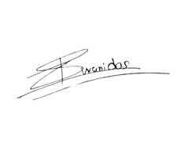

Sincerely Yours

(Authorized Signatory)

Shivani Das

Human Resources-Manager